FOR IMMEDIATE RELEASE
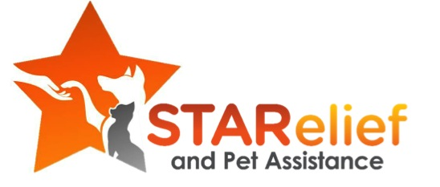
Stamford Animal Control Partners with STARelief and Pet Assistance to
Provide Pet Food to the Community

Stamford, CT - May 6, 2015 - Stamford Animal Control (SAC), in partnership with the nonprofit organization STARelief & Pet Assistance (STARelief), will now provide a source for pet food to community members in need.
People experiencing financial difficulty often come to SAC to surrender their pets. As part of a program intended to stem the tide of pets surrendered to the shelter by owners who can’t afford to keep them, SAC staff will now provide applications for the STARelief & Pet Assistance pet food pantry, which supplies food and other supplies to pet families in need.

According to Tilford Cobb, Acting Director of Stamford Animal Control, “This is an opportunity to help the community. People come to the shelter all the time to ask for help to feed their pets. If we can spare the food, we give it to them. This opportunity gives us the ability to reach the people who are in need”.

Shelter employees can provide applications to visitors who need assistance or online through the Stamford Connecticut Government website at http://www.stamfordct.gov/animal-control-center. The application is easy to fill out and STARelief responds within 72 hours. The STARelief pantry is also located in Stamford so, once the application is approved, it’s easy for people to get access to the dog and cat food they need. In addition, the STARelief pantry can often provide flea and tick control, leashes, collars, toys, bowls and bedding.

“Stamford Animal Control has been really fortunate to receive donations from pet food companies, local pet supply stores, and generous people in the community.” Mr. Cobb added. “But times get tough, and people need a little help sometimes. And if we can’t help them, one day their dog may end up here. We provide shelter for homeless dogs and cats, but we’d much rather see them stay in their homes with their families.”

About Stamford Animal Control:
For more information, please visit http://www.stamfordct.gov/animal-control-center.

About STARelief & Pet Assistance:
STARelief is a 501c3 nonprofit organization whose mission is to provide life-saving pet food, veterinary care, emergency boarding and foster care to pets whose families are struggling with financial hardship. We have programs designed to save pets’ lives, assist families in need, reduce the number of pets entering shelters, and advocate for responsible pet ownership. For more information, please visit http://www.starelief.org. “Like” us on Facebook at www.facebook.com/STAReliefandPetAssistance or follow us on Twitter @stareliefpets.

— ### —
FOR MORE INFORMATION, please contact Officer Tilford Cobb of the Stamford Animal
Shelter at 203-977-5166. Mail inquiries or visit Stamford Animal Shelter: 201 Magee Avenue, Stamford, CT 06902.

